**Rock Climbing History and Culture through Mountain Project Data**

Mike Flanigan

INFO 5602, Final Project

Motivating Problem

Rock climbing is a long-time sport and passion for humans all over the globe. The characters it draws and the stories it has created have built up a rich history in guide books, mountain huts, and campfire stories. However, only in the last two decades has the history, story, and digital data of climbing begun to be accumulated. The de-facto database for the digital knowledge of climbing is MountainProject.com. Created in 2005 it provides a community built and grown gathering place for routes, beta (information), pictures, and the general culture of rock climbing to grow.

The objective of the following project was to create a new and engaging way for climbers to visualize the wealth of knowledge and stories that are encoded in the Mountain Project database. A motivating factor for this project was that there isn't a wealth, or even a small sampling, of data visualizations to help tell the story of rock climbing.

# artifacts

The digital visualizations shown here: [Mnt-Proj-Climbing-History-and-Culture](https://github.com/INFO-4602-5602/Final-Project-Mike-Flanigan/Mnt-Proj-Climbing-History-and-Culture.html) give a deep and exploratory dive into the nature of the knowledge base stored on Mountain Project [4]. With over 200 thousand routes catalogued it represents the largest single database for climbers..

A major part of this project was figuring out how to scrape all of that data from mountain project in a responsible and conscientious way so as not to hurt their website performance… and resultingly get my IP address banned. After much fuzzing fitzing and futsing. A script was ready to run. 3 days later I had access to a database of route knowledge that is on display in the priorly listed visualizations.

Each of the visualizations serves a purpose and helps to tell the story of rock climbing. The audience intended is one of rock climbing enthusiasts who already know most of the basics and who will be excited to have access to further exploratory tools for one of their passions.

# Theory

Some of the expected results of these visualizations were realized. A massive explosion in the popularity of climbing has been reported in the likes of [5] and the visualizations lent concrete evidence to this.

Visual encoding of data attributes to show the progression of climbing pay an enjoyable homage to the history of the “stone men” of the 1980s whose work is well visible in the climbing progression and FA frequency plots [5] [6].

## Related Work

There’s a solid body of climbing information out there. However, most of it is accumulated in raw text or hardly formatted manners [1] [2]. The great achievements have received some coverage from outdoor specific media sights [3] but still there is largely a lack of interactive resources for the interested climber to explore the existing bodies of knowledge. Two of the better visualizations I found while searching for related work are shown below. Figure 1 from [2] showing a sparse world map with the hard climbs info from around the globe. Figure 2 from [4] showing essentially the same thing.

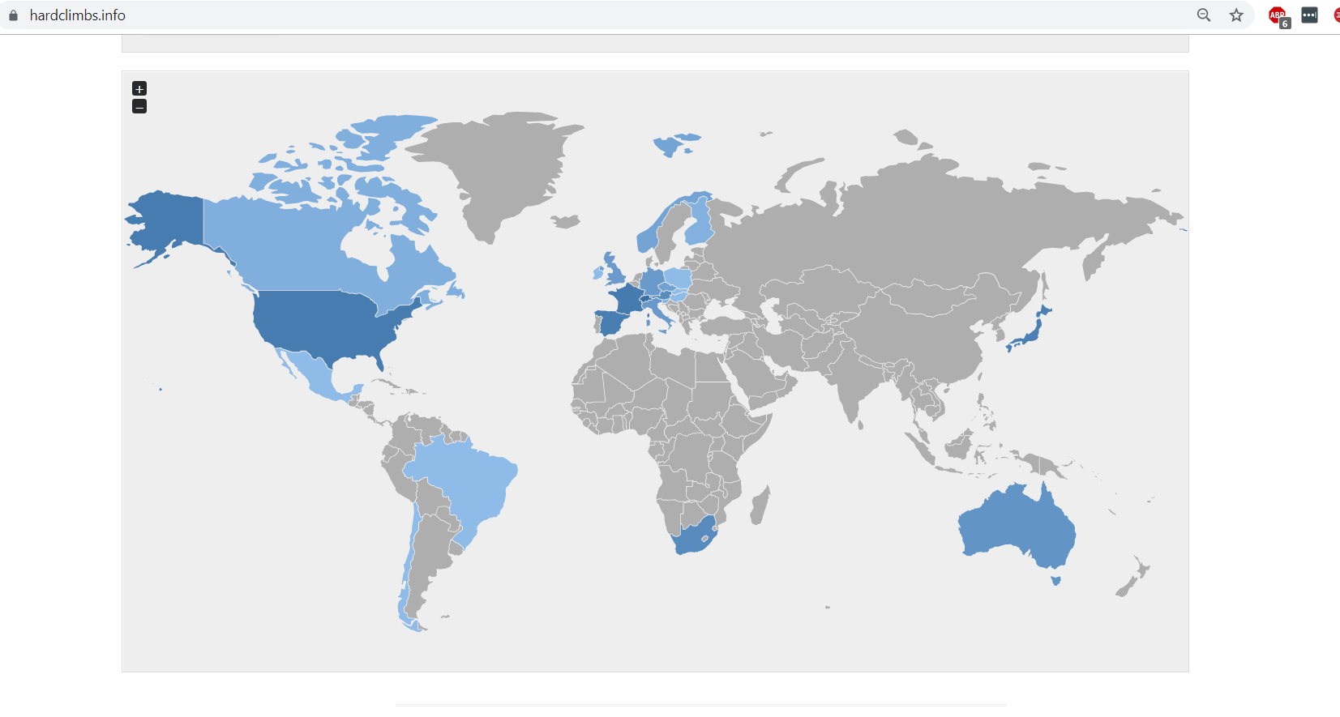

1. 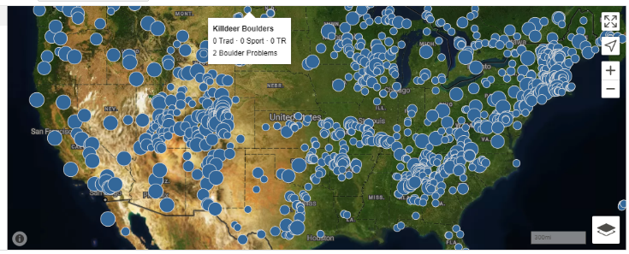Global climbing info.
2. Mountain Project’s US climbing map.

## Detailed Descriptions

There’s some great write ups in-line in the visualization document, and since it’s partly intended to be a data exploratory visualization I think it’s nice for the reader to work through the visualizations and take in the nuances.

* Mifl0205 at Colorado dot edu

# Findings and Conclusion

Early reviews and feedback from several rock climbers who demoed the visualization tools showed excitement and promise. While one review had a negative twinge about the objective use, I happen to know that reviewer is really a good natured rock loving curmudgeon who will likely spend a few hours trying to figure out all the little nooks in the vis despite his claim of no real use. Personally I have been excited to learn a great deal in web scraping, data preprocessing, and web development. The fact that I was able to do that while visualizing huge amounts of rock climbing data which is one of my passions has been a massive benefit of this project. Considering that [7] and [8] initially got me thinking about his style of project due to their popular culture impacts and incredible story telling and data accumulation (respectively).

References

1. [http://www.speedclimb.com/yosemite/thenose.htm#98](http://www.speedclimb.com/yosemite/thenose.htm" \l "98)

1. <https://www.hardclimbs.info/>
2. <https://www.outsideonline.com/2075501/25-greatest-moments-yosemite-climbing-history>
3. <https://www.mountainproject.com/>
4. <http://www.supertopo.com/>
5. <https://senderfilms.com/productions/details/809/Valley-Uprising>
6. <https://en.wikipedia.org/wiki/Free_Solo>
7. <https://en.wikipedia.org/wiki/List_of_first_ascents>